**Introduction**

A website that allows users to buy and sell homemade soap.

# **Flow Chart**

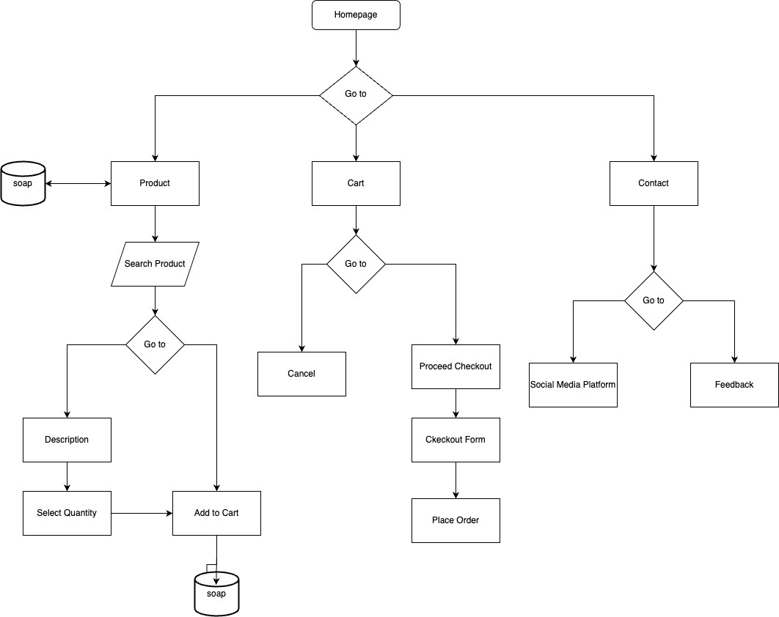

**Screenshots**

Homepage

Best sellers section

Product section

Shopping Cart

Check Out

Contact US

